Reflections on Alternative Spring Break 2026
By Jessica Featherston
Each year, students from the Florida State University College of Law travel to Apopka, Florida to participate in Alternative Spring Break, a four-day program hosted by the Farmworkers Association of Florida. Throughout the program, students learned about immigration, human trafficking, environmental justice and other pressing issues for the farmworker community. 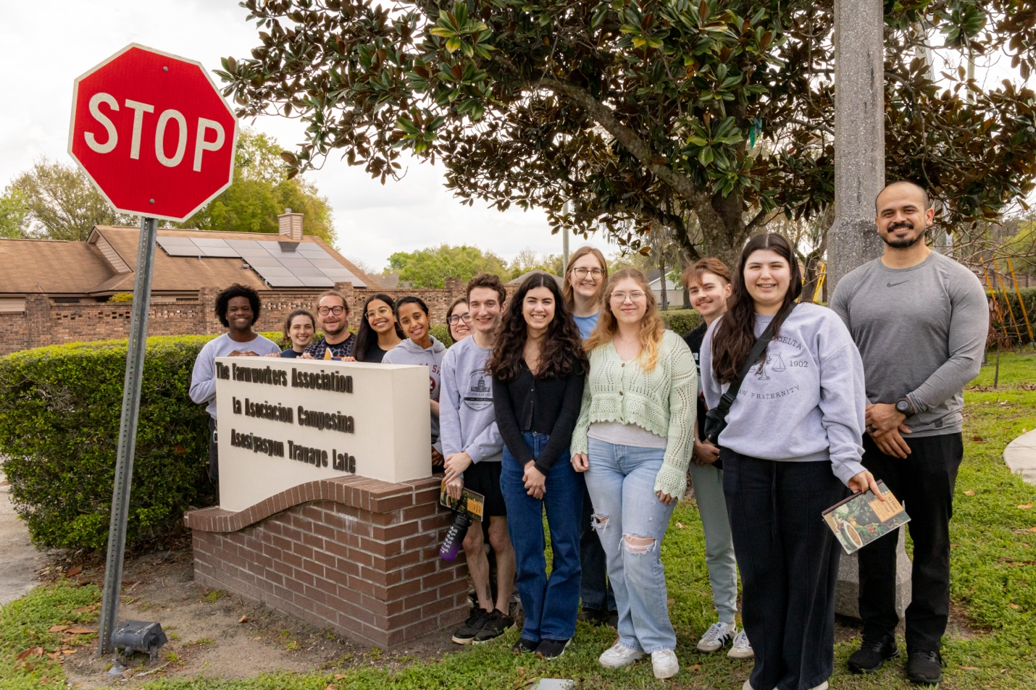
This year, the program centered the harm immigrant communities have experienced since early 2025, when U.S. immigration enforcement began ramping up operations, leading to substantial increases in detention, deportations, and state violence toward immigrant communities. Changes in immigration policy, both at the federal and state levels, have had a harmful impact on migrant farmworkers. Students were able to hear about the lived realities of migrant farmworkers throughout the program, creating a meaningful and lasting impact for all of the students who participated in Alternative Spring Break.
The Human Impact of Environmental Harm
On the first day of the program, students learned about the harmful impacts of pesticides and pollution. While these are typically analyzed for their impact on the environment, students learned the hidden human impact as well. After learning that mass bird deaths occurred due to eating fish from the heavily polluted Lake Apopka, 1L Kiara Videla reflected, “I felt frustrated that the next logical step to do testing on the humans was neglected. That when these farmworkers had skin rashes, or birth defects that no one seemed to care, yet they continued to benefit from their physical labor.” 3L Sydney McLain discussed the human impact of environmental harm stating, “With the Clean Water Act, I would imagine pollution relative to the fish in the water, or the birds that migrate through wetlands. However, this presentation made me realize that environmental pollution affects so much more than just that. If the pollution at a factory or a farm kills animals around the location, it’s never only animals that are affected. There are always workers that are the closest to the source, and the communities around it are also at risk.”
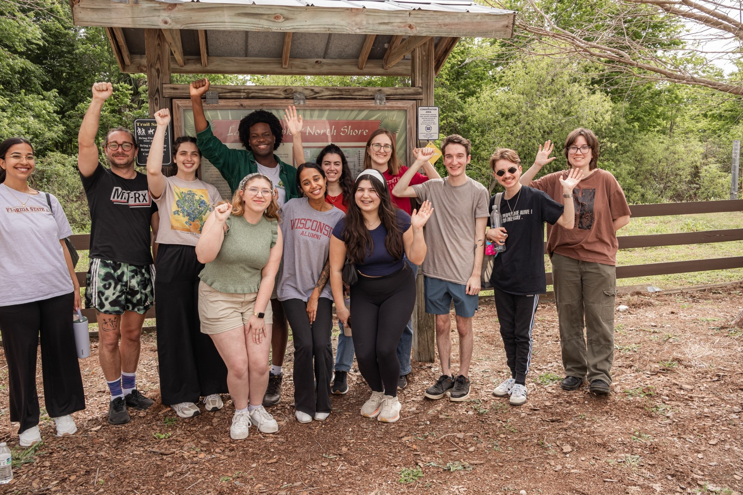
Many farmworkers have suffered from severe health conditions, including terminal illnesses, reproductive difficulties, and premature death, as a result of prolonged pesticide exposure and a lack of adequate safety precautions on the part of the farm owners. As 2L Avery Bell put it, “The farmworker community is exposed to carcinogenic pesticides, low wages, fear of deportation, and on top of all of this most of them don’t get health insurance through their work. I was most shocked at how much damage pesticides have done over the years to these farmworkers. From permanently scarred skin to mysterious illness from the runoff, pesticides harmed the people, the water, and the land all the same. I knew that pesticides were bad but I have never seen its negative effects on actual people and places.”
After learning about the harms of pesticides, Jeannie Economos of the Farmworkers Association took the students on a guided tour of Lake Apopka and the surrounding community. During the tour, students visited the home of Linda Lee, a former farmworker. Linda Lee and her children suffered severe health consequences as a result of her pesticide exposure. She spoke to the students on a video call from the hospital, where her health complications were being treated. Linda Lee now creates beautiful quilts that incorporate her lived experiences and culture. Two of her friends displayed the quilts to the students outside her home.
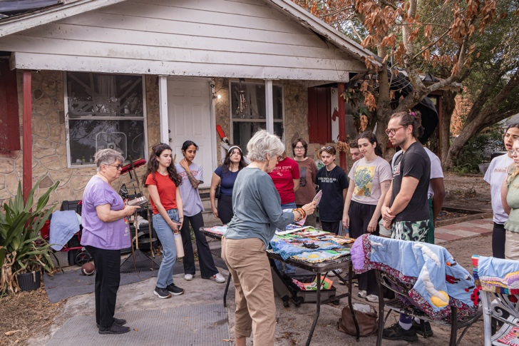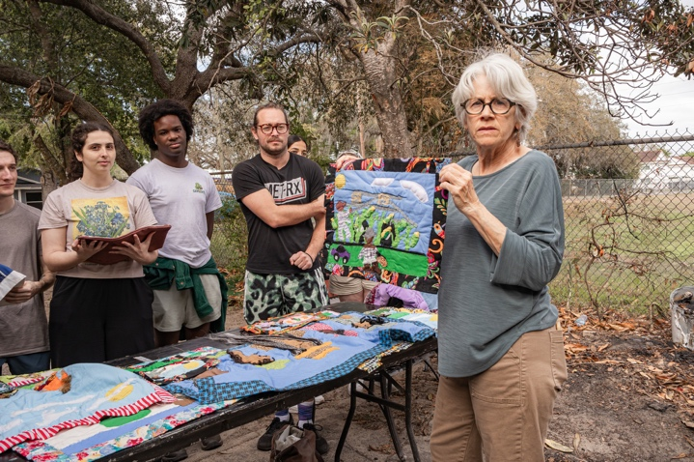
Shared Work, Shared Lessons
On the second day of the program, students worked alongside farmworkers at a local nursery. The students were required to watch a pesticide training video before they could begin. Upon viewing the video, 2L Elliot Weber commented, “I felt like a lot of the suggestions they had for farmworkers were unrealistic. They asked them to wash their clothes in separate laundry loads, and to rinse their machines twice before washing anything else. If you aren’t making much money, you don’t want to raise your utility bill with multiple loads and extra rinses. Also, if you’re working 12 hours a day for six days a week, chances are you don’t have time to do this either.”
Students then divided into smaller groups to work on different tasks in the nursery, including arranging potted plants, clearing out plants that were no longer sellable, sweeping dirt out of the greenhouses, and labeling plants. 3L student Annalena Zinati-Milon reflected on the work, stating, “Although we were assigned relatively simple tasks compared to their daily labor, the heat in the greenhouse was intense. Even on a cooler day, I found myself drenched in sweat. This experience gave me a deeper appreciation for the conditions farmworkers endure, often far more extreme, for long hours, most days of the week. We then spent the remainder of the day indoors, listening to guest speakers in the comfort of air conditioning, a stark contrast that made our privilege especially clear.” 1L Meghana Raj also found the experience impactful, stating “While placing stickers on pots may seem simple, it allowed me to work alongside farmworkers and engage in meaningful conversations. I spoke with a young man from South Africa who was in the United States on a J-1 visa. On paper, these visas are designed to promote cultural exchange, but in practice, they often function as tools of labor exploitation. He described long hours, limited protections, and the constant pressure to comply due to the temporary nature of his status. This interaction highlighted a key issue: legal status does not necessarily equate to protection from exploitation.”
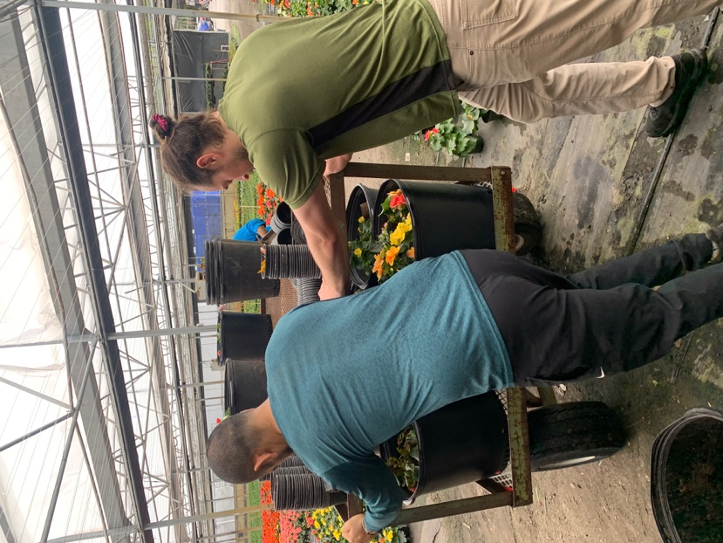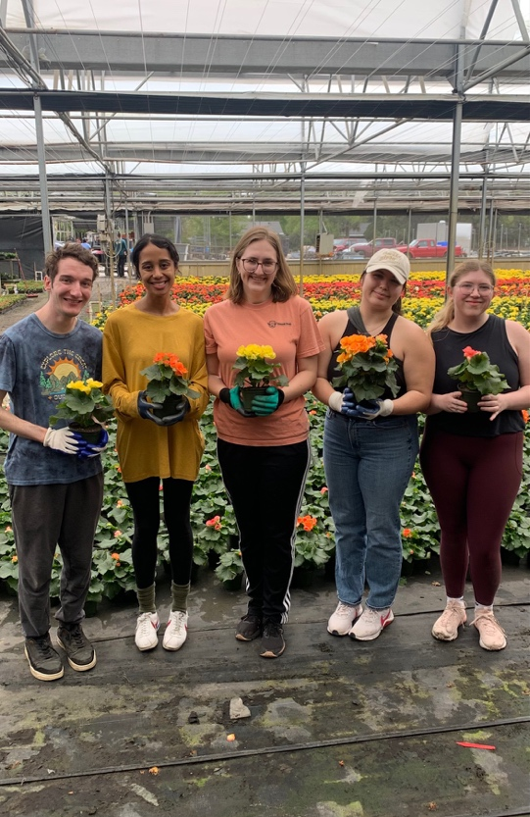
The next day, students worked in Apopka’s community garden. The students helped create new soil through composting—they dug large holes, filled them with used cardboard boxes, covered them with sticks, and then covered the holes with dirt. Unlike the nurseries and farms where they are employed, farmworkers and community members are able to reap the benefits of the labor they put into the community garden. Everyone shares in the labor, and everyone shares the food it produces. The garden serves as a way for the community to care for each other and put their labor back into their community, rather than toward corporate profit.
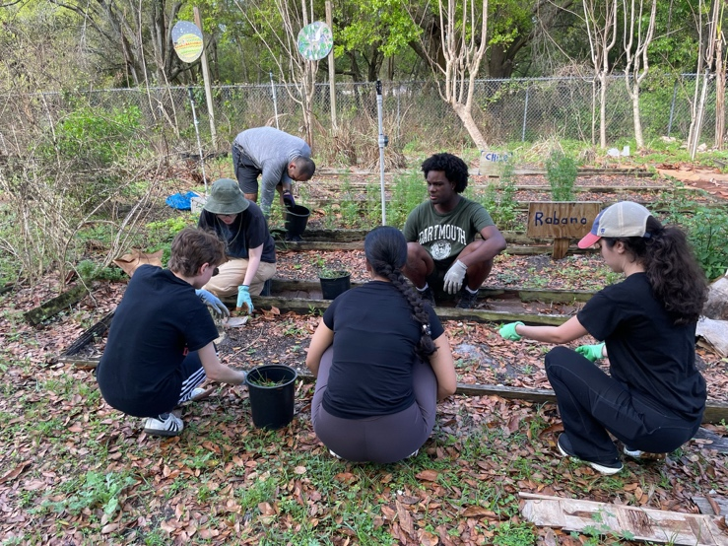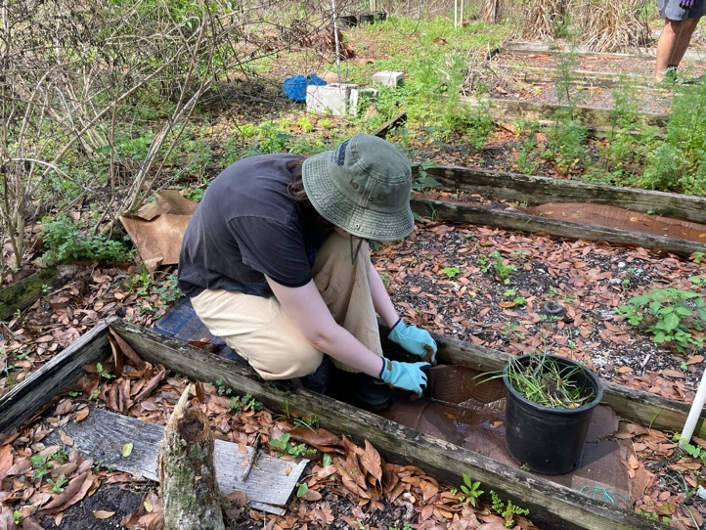
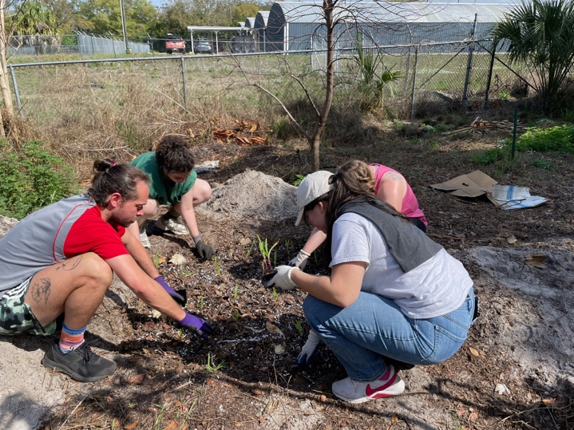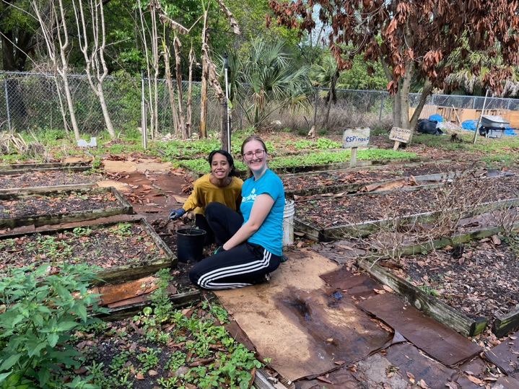
Stories That Stay With Us
Each day, the students were able to learn from local activists, attorneys, and even migrant farmworkers themselves. First, an immigration attorney, Giselle Martinez, discussed the ongoing immigration crackdown and the need for reform. Students were struck by how changing immigration policies over the past year have impacted Ms. Martinez’s work and clients—including clients who had been in the middle of the process to gain lawful residency being abruptly detained and deported. Next, Rene Gomez, of the Farmworkers Association, presented on the real-world impacts of anti-immigration policy on Apopka’s farmworker community. He discussed how frequent ICE raids and intimidation tactics resulted in a community that felt that they could no longer speak out about harms and abuses they faced for fear that they would draw unwanted attention to themselves. 2L Sarah Chair reflected, “Hearing from Rene about the real world impacts of the ICE activity in Apopka was illuminating. The activity of ICE that occurs in Apopka is not reported on in national news, but it is the activity that is impacting the most people.”
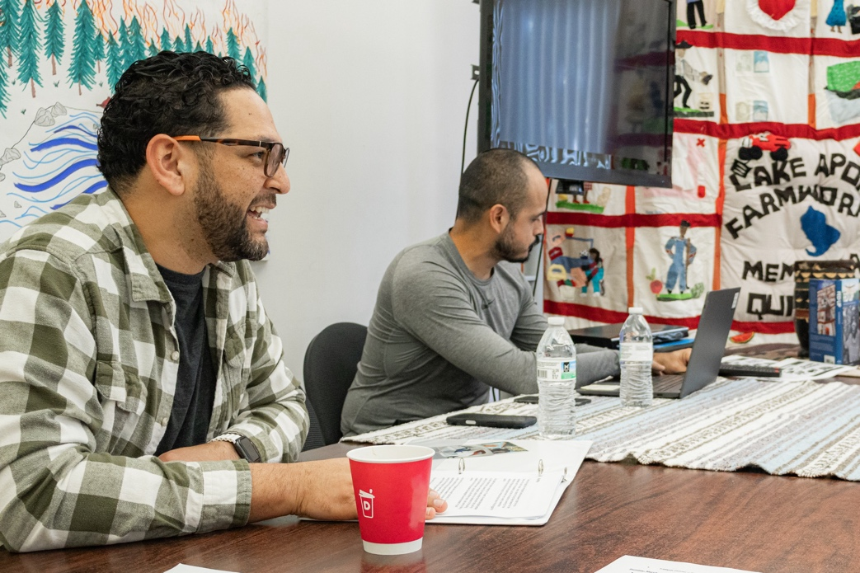
Later that day, four young members of the Farmworkers Association’s youth group, Bradley, Miguel, Aaron, and Valeria, engaged the students in a discussion about their backgrounds and activism. They talked about their families’ experiences with the U.S. immigration system and its impact on their lives. Gaby Mawad, 3L, stated: “They shared their own stories about growing up in families with mixed immigration statuses and what it is like to grow up with the fear of potentially losing your parents at any moment. Despite this heavy burden, these teenagers and young adults continue to advocate for themselves and other immigrants through their work with FWAF. They do so through community presentations, outreach, and even advocating for immigrants in the Florida state legislature. Hearing their personal stories and community activism was both inspiring and sobering to see how they have to carry the burden of advocating for basic rights that I frequently take for granted.” The students also shared some of their experiences with the youth group members, with the Farmworkers Association fostering an open dialogue about identity, systemic issues, and activism efforts.
The next day, Karen Woodall, progressive lobbyist and Executive Director of the Florida People’s Advocacy Center in Tallahassee, discussed the most recent Florida legislative session and bills that could pose serious risks to immigrant, farmworker, and activist communities. Grace Patterson, 1L, found this particularly impactful, reflecting that the presentation “illustrated how lawmaking at the state level can disproportionately impact migrant communities and advocacy groups. In particular, HB 1471, legislation that permits state officials to designate organizations and individuals as domestic terrorists poses a unique threat to groups whose missions conflict with the state’s ideology. The law threatens the free speech protections of Florida’s political minority, dangerously chilling the very expression that the First Amendment was aimed at protecting.”
Next, Florida Legal Services attorney Anne Piervil discussed her work with Haitian farmworkers and the immigration system. The Farmworkers Association’s Yesica and Chepe then shared their personal testimonies from crossing the border. The students found Yesica and Chepe’s stories to be extremely impactful, and tears were shed from all around the room. Anthony Mortellaro, 3L, stated: “Hearing from kids in the youth group, who have been thrusted into advocacy by the current administration, and from Jose and Yessica reminded me that the law has a human impact. Even with staying up to date with the news, it is easy to forget that people are living and struggling through the consequences of the last election.” The students finished the day by turning their reflections into creative output, making posters that symbolized their reactions to everything they had experienced thus far during the program.
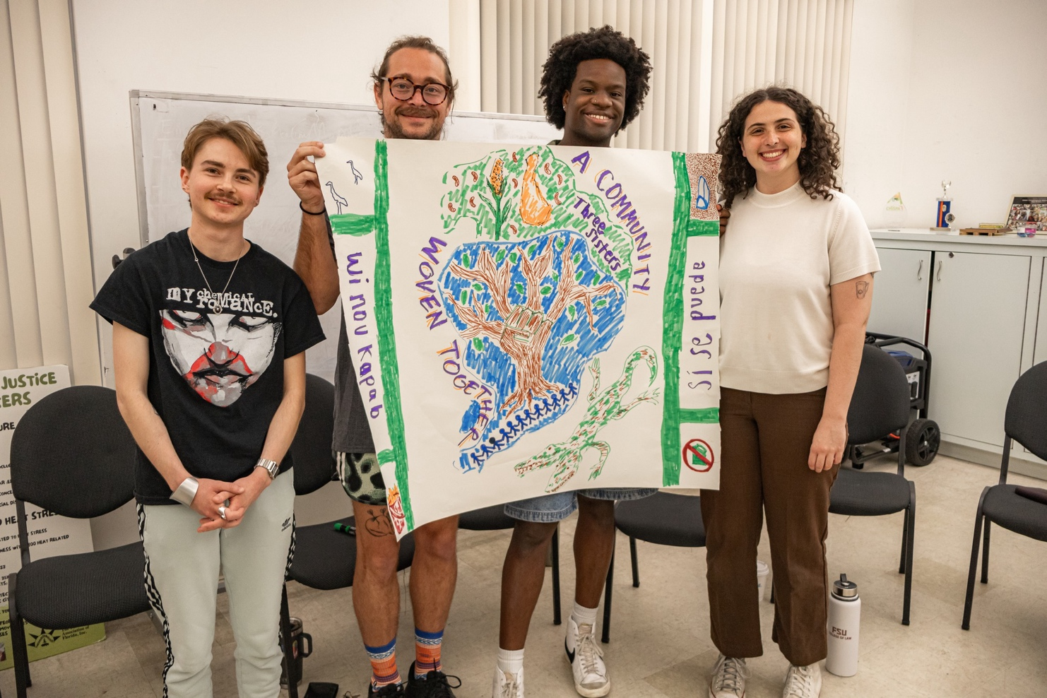
While the last day of the program is typically reserved for discussions of human trafficking, Jeannie explained that this year, because of the severe immigration policies that had devastated immigrant communities, it would be mostly dedicated to immigration. The students heard from Ingrid Morfa, a local immigration attorney, as she discussed the different paths to citizenship available and the realities for immigrants who attempted to utilize them. Andrea Montanez, Field Organizer for the National LGBTQ Task Force, then discussed her experience as a transgender immigrant, informing the students that, because of her expression of her gender identity, she would likely face extreme violence and potentially be killed were she to be deported. The students were taken aback by her strength and resilience, and at the end of her presentation, Ms. Montanez led the students in a powerful chant: “¡No más pendejos!”
Socrates Perez, a local pastor, discussed the role of religious leaders in defending and protecting immigrants’ rights. Then, Meg Johnson from SafeHouse of Seminole presented about the prevalence of human trafficking, particularly within the farmworker community. At the end of the day, the students joined hands in a circle with Jeannie, Rene, and Dom from the Farmworkers Association. They reflected on their experiences throughout Alternative Spring Break, and the fight before them to ensure safety, security, and dignity for all immigrants and farmworkers.
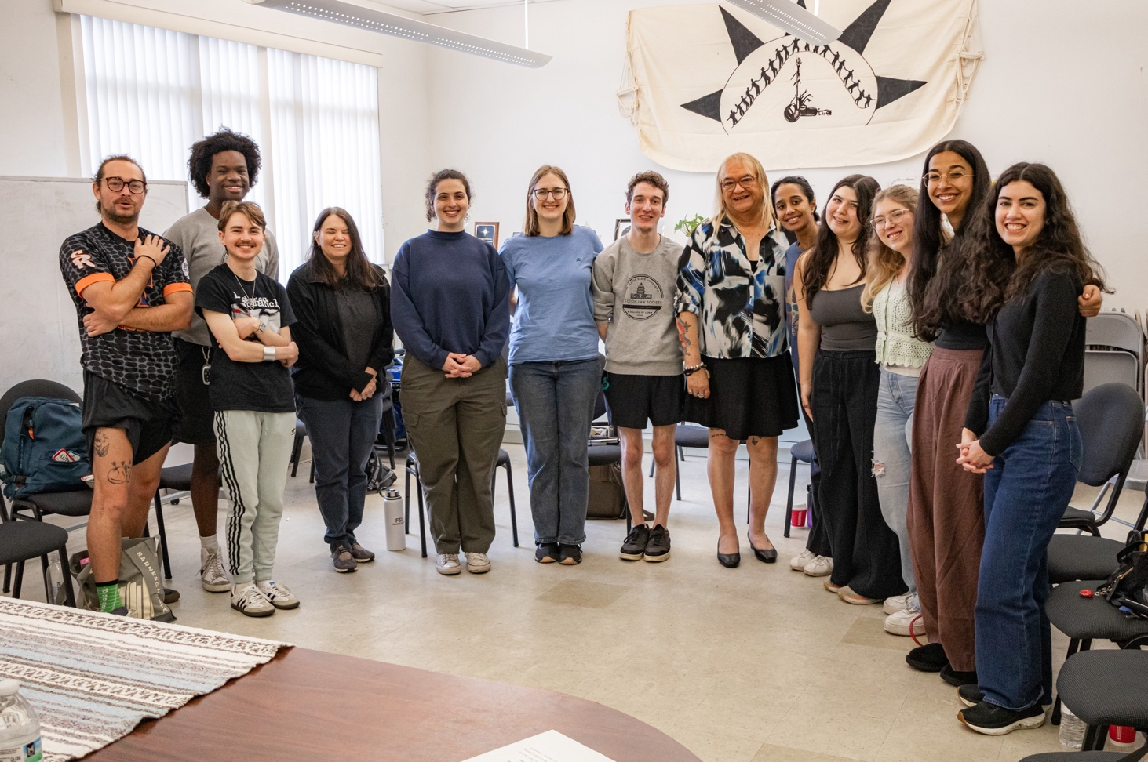
Reflections on Alternative Spring Break in Their Own Words
Jessica Featherston, 3L student and author of this article, would like to convey her deepest gratitude for the Farmworkers Association’s hard work in putting together this program, to FSU Law for offering this opportunity, and to each of the speakers for sharing their experiences, even when it is difficult to do so. Alternative Spring Break is a truly transformative program which has irrevocably changed the lives of the students who participated in it. At a time when speaking out can be dangerous and discouraged, the Alternative Spring Break program offers a sense of community and shared purpose. Together, we can find a way through to the light. Through building community and fighting for change, we will restore justice and dignity for all.
Each student who participated in Alternative Spring Break expressed the feeling that they will carry this experience with them throughout their lives. Some highlighted quotes from the students are included below.
- “Alternative Spring Break was one of the most impactful experiences I have had at FSU College of Law. The people that work at the Farmworkers Association of Florida are incredible. Jeannie, Rene, and Dom were inspiring to meet. Their passion for the farmworkers and the community, in general, reminded me of why I came to law school in the first place. [ . . . ] There are members of our community who are in the cross hairs and we have a duty to not abandon them out of convenience. Alternative Spring Break reminded me of that and has reinforced this belief in me. It is something I will take with me forever.” – Anthony Mortellaro, 3L
- “I was able to learn about so many local issues from a community not far from the place where I grew up. This experience reminded me of the sacrifice immigrants make to come here and provide important services such as feeding the nation. It also reminded me of what a disservice this country does to immigrants and farmworkers. This experience reminded me of the power of people's stories, the importance of community activism, and the need for immigration reform. I hope to share what I learned about the work of FWAF with my own community and take that same spirit of activism and advocacy into my career as a new attorney.” – Gaby Mawad, 3L
- “Hearing personal testimonies from people who had actually made the crossing from Mexico to the United States, as well as hearing from youth in the community who were engaged in advocacy and feared that their parents may be taken away was difficult to hear but also incredibly important to developing an understanding of how these legal issues have detrimental effects on people. This was an incredibly developmental experience that I am lucky to have experienced during my 1L year so that I can carry it with me throughout the rest of law school and into my legal career.” – Josh Carson, 1L
- “Overall, law school often does not and sometimes will not reflect the reality of the outside world in pursuit of the classroom education that makes it difficult to understand and grasp the ramifications of what we are taught. This program flips that narrative. By experiencing the world outside of the classroom, I learned so much and my understanding deepened to a level that cannot be taught in a classroom. I am immensely grateful for this experience and I believe that everyone, especially people who are committed to public interest work, should go on this program.” – Sarah Chair, 2L

